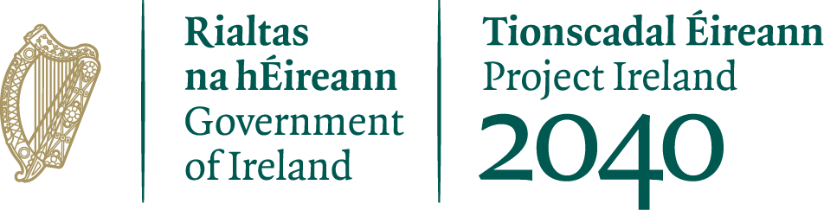

Community Recognition Fund 2023
Expression of Interest Form

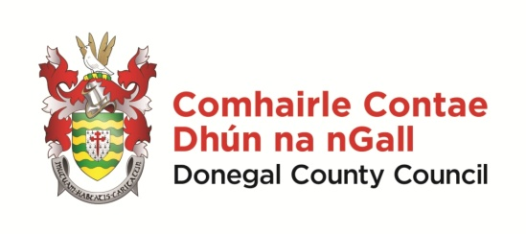
FOR OFFICE USE ONLY

Date Received:

Reference Number:

LCDC recommendation:

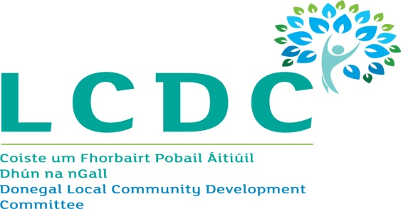

ALL APPLICATIONS MUST BE RETURNED TO:
Donegal LCDC
Community Development,
Donegal County Council, Station Island, Lifford, F93 X7PK, Co Donegal or by email to lcdc@donegalcoco.ie

By 3pm on Monday, 6th March, 2023
CLOSING DATE WILL BE STRICTLY ADHERED TO.

Guidance for Applicants

Background

The Community Recognition Fund 2023 was launched by the Minister of Rural & Community Development, Heather Humphries TD on Tuesday 24th January, 2023.
This Fund aims to support the development of community infrastructure and facilities in recognition of the contribution being made by communities across the country in welcoming and hosting significant numbers of arrivals from Ukraine and other countries.
The funding is specifically targeted at projects that are located in communities, towns and villages that are hosting the Beneficiaries of Temporary Protection and/or International Protection Applicants.
The Fund aims to support the development of facilities that will be used in the future by all members of the community. It is separate in its objectives and scope to any other public funding streams which aim to support the development of public service needs arising from the significant number of arrivals from Ukraine.
€50 million is available nationally under the Fund and this is allocated between each local authority based on the number of new arrivals located there. On this basis, the allocation to County Donegal is €3,114,395.
The scheme is being administered on behalf of the Donegal Co Co by the Donegal Local Community Development Committees (LCDC)
The deadline for receipt of completed EOI applications is 3pm on Monday, 6th March 2023.

Eligible Projects
Projects to be funded will be capital in nature, deliver tangible benefits for the communities in which they are located, and be capable of being delivered over the course of 2023 and 2024. A minimum spend of 60% of the allocation must be incurred in 2023. Eligible projects will receive funding for capital costs, but not for any ongoing operational or running costs.
Local authorities have scope to invest the funding based on their own distinct local needs as identified through a “bottom-up” approach based the community engagement referenced above.
However, the type of projects eligible for funding are:
• Development, enhancement or refurbishment of community or cultural facilities including play areas, walkways, parks, community/sensory gardens including communication boards, allotments, and recreational areas;
• Development, enhancement or refurbishment of local club and sports facilities including facilities such as community swimming pools, changing rooms, toilets, digital aids such as score / information boards etc.;
• Enhancement to school/parish facilities which are open to use by all of the community after school hours;
• Purchase of equipment for local clubs, festivals, community events and organisations e.g. music, arts or sports equipment;
• Transport infrastructure such as the purchase of community vehicles, bus shelters and attendant information boards; and
• Purchase and refurbishment of buildings and/or the purchase of land for the development of community facilities such as play areas/ MUGAs or town parks/ community gardens, recreational areas etc. for community use where a clear need is identified

Funding Allocation

Amounts approved to organistaions will be subject to the total number of applications approved and the overall budget available (€3.1 million). This funding scheme will provide large capital grants ranging from €25,000 to a maximum of €250,000 with a requirement that projects are fully complete by 18th October 2024.

Eligible Costs

Under this scheme, grants will be provided towards large scale capital costs. Capital costs incurred for the purchase of equipment are eligible. Repairs and refurbishment of existing facilities can also be funded.
The scheme does not provide funding for operating costs (e.g. the employment of staff, electricity costs, heating costs, etc.) or administrative costs.
Only expenditure incurred after the date of grant approval will be eligible.
The grant may cover all, or part of, the purchase or works in question. However, the full cost of the project must be provided on the EOI Form.
This funding should not be used as a co-funding source for other Government Department Schemes

Applications

Applicants will be notified of the outcome of the EOI process by the LCDC by 16th March 2023, following which the LCDC will enage with shortlisted applicants to determine whether projects can be fully complete before 18th October 2024.

Terms and Conditions

- Projects situated in areas that do not have high levels of new arrivals will not be deemed eligible.
- The information supplied by the applicant must be accurate and complete. Incomplete applications will not be considered for funding.
- Misinformation may lead to disqualification and/or the repayment of any grant made.
- All applicants group/organisations must be registered for tax and be tax compliant, in line with revised tax clearance procedures, which came into effect in January 2016.
- Applications must include Tax Registration No/Tax Clearance Access No or Charitable Status No

- All information provided in respect of the application for a grant will be held electronically. The Council reserves the right to publish a list of all grants awarded on its website.
- The Freedom of Information Act applies to all records held by Donegal County Council.
- The application must be signed by the Chairperson or CEO/MD of the organisation.
- It is the responsibility of each organisation to ensure that it has proper procedures and policies in place including appropriate insurance where relevant.
- Evidence of expenditure, receipts / invoices must be retained and provided to the LCDC or their representative if requested.
- Publicity guidelines must be adhered on all materials associated with the purposes of the grant in accordance with Section k and appendix 3 of the Scheme Outline.
- Generally no third party or intermediary applications will be considered.
- Late applications will not be considered.
- Applications in any form (hardcopy or e-mail) should arrive not later than the closing date of 3.00pm on Monday, 6th March 2023.
- Claims that any application form has been lost or delayed in the post will not be considered, unless applicants have a Post Office Certificate of Posting in support of such claims.
- Breaches of the terms and conditions of the grants scheme may result in sanctions including disbarment from future grant applications.
- By completing this Application Form, you consent to the data on the form, as required, being transferred to the Department of Rural and Community Development to enable a decision to be made on your application.
- Successful applicants may be subject to audit by the LCDC or the Department of Rural and Community Development.
- Documentation relating to the purchase of equipment or the completion of works should therefore be maintained for inspection for a period of 7 years.
- The ‘de minimus’ rule (Commission Regulation (EC) 1407/2013) will apply to the operation of this funding scheme.

Enquiries

Applicants will be advised that all enquiries in relation to the Community Recognition Fund 2023 should be directed to lcdc@donegalcoco.ie

Organisation Details

Name of Organisation:
Contact Person:
Role of Contact Person:
Contact Correspondence Address:

Eircode:
Contact Email Address:
Contact Telephone No.:
Organisation Website:
Tax Reference Number (if applicable):
Tax Clearance Access Number (if applicable):
Charity Number (if applicable):
Main Objectives/Purpose of Organisation:

Failure to provide Charitable Status No or Tax Reference No or Tax Clearance Access No relevant to your group will deem application invalid

Details of Proposed Project

What will the funding be used for?
Outline how the proposed project will deliver tangible benefits to your community.

Give details of your organisation’s engagement with new communities in your area:

Total Estimated Costs of Project – Evidence and breakdown of costs i.e. Quotation or QS estimate must be submitted: | €
Amount being applied for:  (Minimum €25,000 – Maximum €250,000) | €
To be eligible for funding under this programme you must state where you will source any shortfall of funding: | €
Provide documentary evidence of legal interest in your premises/property, Owner/Lease/Renting:
Please provide copy of planning permission where relevant:
Proposed timeframe associated with Project:

In order to process your application it may be necessary for Donegal LCDC to collect personal data from you. Such information will be processed in line with the Local Authority’s privacy statement which is available to view on http://www.donegalcoco.ie/footer/dataprotectionstatement/.

I confirm I have read and fully understand the Terms and Conditions of this Programme (see page 4 of this form). | Yes/No: _________
I confirm that I have read and fully understand the ‘Statement on Public Finances’ contained in Appendix A  (see page 9 of this Form) | Yes/No: _________

I confirm that I have read and understood this document and declare that the particulars supplied in this funding proposal are true and correct and that –
- The costings are accurate and reasonable.
- All necessary permissions are in place e.g. planning consent etc.
- All relevant ecological survey work (if applicable) has been undertaken or will be undertaken e.g. Appropriate Assessment screen.
- There is evidence of ownership (if applicable) or the consent of the landowner.
- The project will comply with Public Procurement Guidelines.
- The project conforms to the LECP and other local or regional plans.
- No funding has been allocated for the same works from any other sources.

I declare that the information provided by me on this application form is truthful and complete.

Signed: _______________________________ Date:____________________
Print Name: ______________________________

Position in Organisation: ____________________________
(Must be Chairperson or CEO/MD)

APPENDIX A

Statement on Public Finances

This Statement should be brought to the attention of every grant receiving body

If you are in receipt of public funding you should

Clarity  Understand the purpose and  conditions of the funding and the  outputs required  Apply funding only for the business  purposes for which they were  provided  Apply for funding drawdown only  when required for business purposes  Seek clarification from the grantor  where necessary – on use of funds,  governance and accountability  arrangements | Governance  Ensure appropriate governance  arrangements are in place for:  Oversight and administration of funding  Control and safeguarding of funds from  misuse, misappropriation and fraud  Accounting records which can provide, at any time, reliable financial information  on the purpose, application and balance remaining of the public funding  Accounting for the amount and source of the funding, its application and  outputs/outcomes
Value for Money  Be in a position to provide evidence on:  Effective use of funds  Value achieved in the application of funds  Avoidance of waste and extravagance | Fairness  Manage public funds with the highest  degree of honesty and integrity  Act in a manner which complies with  relevant laws and obligations (e.g. tax,  minimum wages)  Procure goods and services in a fair and  transparent manner  Act fairly, responsibly, and openly in your  dealings with your Grantor

CHECKLIST:

Signed and completed Application Form □

Details of Charitable Status or Tax Reference or Tax Clearance Access No □

Documentary Evidence of Interest in Premises/Property □

Copy of Planning Permission (where relevant) □

Quotations or Estimates □

